1. **Identify Bus matrix for your business processes against common dimensions (state which facts will use which dimensions)**

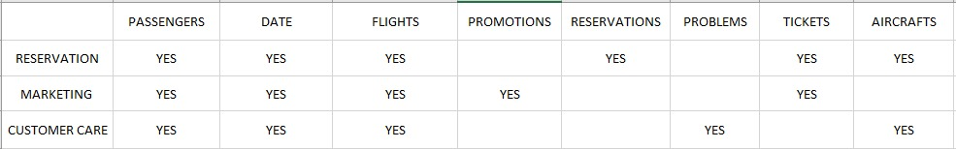

1. **State the dimensional modeling process for each business process**

**Step1: Select the Business Process:**

* Marketing
* Reservation
* Customer Care

**Step2: Declare the grain:**

Atomic

**Step3: Identify the Dimensions:**

* Reservation Channel Dimension
* Promotions Dimension
* Tickets Dimension
* Date Dimension
* Aircrafts Dimension
* Flights Dimension
* Problems Dimension
* Passengers Dimension

**Step4: Identify the facts**

* Marketing
* Reservation
* Customer Care

1. **Using any diagramming tool you like, construct a logical data model for this case study. Output should be an image or PDF. State why did you choose this particular data model design? What does the data represent? (Details about each model component is necessary).**

**6. Construct a sample of SQL queries (5 – 8 queries) using your physical model design which can be used to answer possible questions by the decision maker as described in the case-study above. List the business question with each query (Output should be a Word file)**

1. **what flights the company’s frequent flyers take?**

1. **what fare basis they pay?**

1. **how often they upgrade?**

1. **how long their overnight stays are?**

1. **what proportion of these frequent flyers have gold, platinum, aluminum, or titanium status?**

